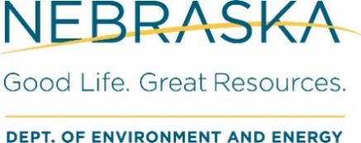
Submit completed form to:
Drinking Water and Groundwater Division PO Box 98922, Lincoln NE 68509-8922 Phone: 402.471.2186 Fax: 402.471.2909
ndee.ecmupload@nebraska.gov

Community Public Water Supply System
Capacity Development Statement of Intent
I, [Owner Name], intend to own [System Name], a new community public water supply system, for the foreseeable future.

☐ Yes ☐ No

If you checked ‘No’ above, please provide the new owner contact information below:
Name: [Name]
Address: [Address]
Phone: [Phone] Email: [Email]

This facility plans to meet the minimum technical, managerial, and financial capacity requirements of a new community public water system with the following proposed operating budget. Available projections for years two through five are also provided.

Proposed Operating Budget for the Community Water Supply System

 | Year 1 | Year 2 | Year 3 | Year 4 | Year 5
I. Income
A. Operating Revenues (e.g., water charges, service connection fees, other revenues)
B. Reserve Accounts
1. Emergency Reserve
2. Capacity Replacement
C. Budget Surplus
D. Financing Source
Grants
Reserves
Loans
User Surcharge
Total Income
II. Expenses
A. System Operating Expenses (e.g., salaries & other benefits, contract labor, power costs, insurance, professional services)
B. Taxes
C. Debt Payments
D. Miscellaneous (e.g., training, travel)
E. Capital Improvement Costs
Total Expense
Income Less Expense

