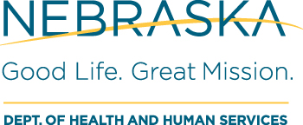
DHHS Water Well Standards
PO Box 98922
Lincoln NE 68509-8922
Phone: 402-471-0546 | FAX: 402-471-6436

Please Type or Print Clearly
ATTACHMENT 1

State of ) AFFIDAVIT OF COMPLETION OF CONTINUING EDUCATION PROGRAMS

County of )

[Name] being first duly sworn, deposes and says:

1. That he/she is the person completing this form.

2. That he/she lives at [Street, PO Box], [City], [State], [ZIP], [Telephone Number].

3. That he/she holds a license issued by the Department of Health and Human Services, Division of Public Health, under the Nebraska Water Well Standards and Contractors’ Licensing Act, Number .

4. That for the period between [Month/Date/Year] and [Month/Date/Year], he/she has completed the continuing education courses named below on the dates and at the locations described and for the number of hours set forth below:

PROGRAM NAME/PROVIDER | PROGRAM LOCATION | PROGRAM DATES | HOURS EARNED

- That copies of all certificates or other evidence of completion provided by the program sponsor for each program listed in paragraph 4 are hereby attached and made a part hereof. Proctors name must also be provided when submitting webinar requests. (Enclose copies of all such documents with the filing of this affidavit.)

Further affiant saith not.
(Signature)

Sworn to and subscribed before me on the ______ day of , 20____.

SEAL NOTARY PUBLIC

